# CSE 4308

## LAB 5 ASSIGNMENT

Task statement:

Our main goal for this task was to showcase various SQL commands by writing complex queries to show different information from given information.

Solution approach:

For the solution, we had to use functions such as LEFT JOIN, EXTRACT, UPDATE and we also had to use nested queries in order to match primary keys between separate tables and maintain data integrity.

A snippet of the solution is provided below:

1

SELECT C.CUSTOMER_NAME, C.CUSTOMER_CITY

FROM CUSTOMER C

JOIN BORROWER B ON B.CUSTOMER_NAME = C.CUSTOMER_NAME

LEFT JOIN DEPOSITOR D ON D.CUSTOMER_NAME = C.CUSTOMER_NAME

WHERE D.ACCOUNT_NUMBER IS NULL;

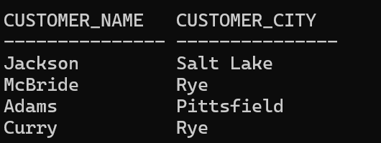

2

SELECT C.CUSTOMER_NAME, C.CUSTOMER_CITY FROM CUSTOMER C WHERE C.CUSTOMER_NAME IN

(SELECT B.CUSTOMER_NAME FROM BORROWER B WHERE B.LOAN_NUMBER IS NOT NULL)

AND C.CUSTOMER_NAME IN (SELECT D.CUSTOMER_NAME FROM DEPOSITOR D WHERE D.ACCOUNT_NUMBER IS NOT NULL);

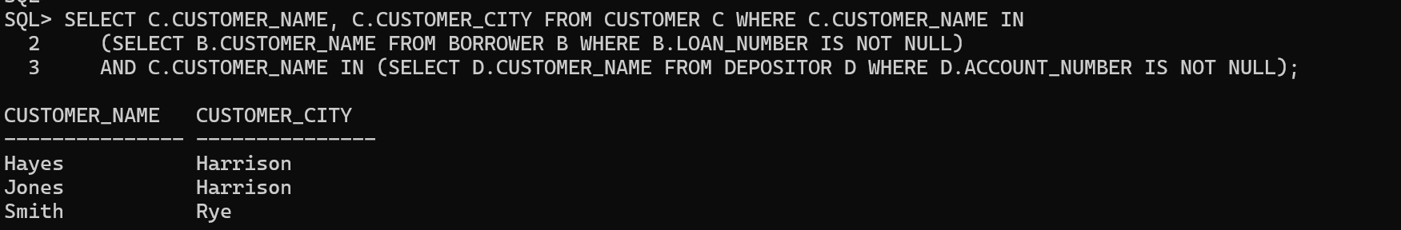

3

SELECT EXTRACT(MONTH FROM (ACC_OPENING_DATE)) MONTH, COUNT(ACCOUNT_NUMBER) FROM ACCOUNT

GROUP BY EXTRACT(MONTH FROM(ACC_OPENING_DATE));

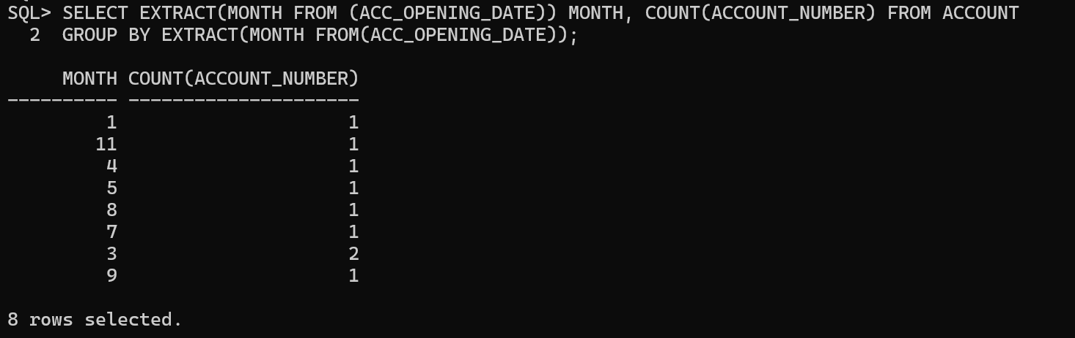

4

SELECT MONTHS_BETWEEN(MAX(L.LOAN_DATE), MAX(AA.ACC_OPENING_DATE)) AS MONTHS_BETWEEN FROM

(SELECT B.CUSTOMER_NAME, B.LOAN_NUMBER, A.ACC_OPENING_DATE FROM

(SELECT CUSTOMER_NAME, ACC_OPENING_DATE

FROM DEPOSITOR D, ACCOUNT A

WHERE D.ACCOUNT_NUMBER=A.ACCOUNT_NUMBER) A, BORROWER B

WHERE B.CUSTOMER_NAME='Smith' AND B.CUSTOMER_NAME=A.CUSTOMER_NAME) AA, LOAN L WHERE AA.LOAN_NUMBER=L.LOAN_NUMBER;

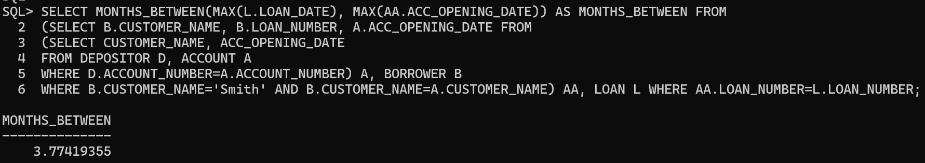

5

SELECT A.CUSTOMER_NAME,A.TOT_BALANCE FROM

(SELECT CUSTOMER_NAME, SUM(BALANCE) AS TOT_BALANCE

FROM DEPOSITOR D, ACCOUNT A

WHERE D.ACCOUNT_NUMBER=A.ACCOUNT_NUMBER

GROUP BY CUSTOMER_NAME) A

WHERE A.TOT_BALANCE=(SELECT MAX(TOT_BALANCE)

FROM (SELECT CUSTOMER_NAME, SUM(BALANCE) AS TOT_BALANCE

FROM DEPOSITOR D, ACCOUNT A

WHERE D.ACCOUNT_NUMBER=A.ACCOUNT_NUMBER

GROUP BY CUSTOMER_NAME));

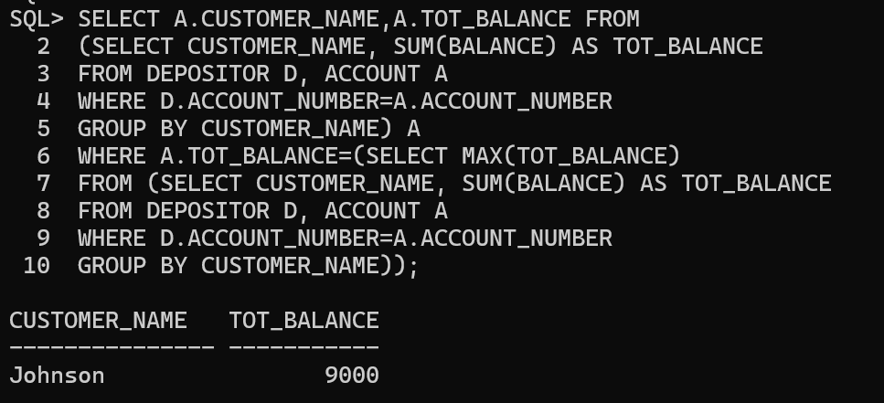

6

SELECT DISTINCT BR.CUSTOMER_NAME || ' ELIGIBLE' FROM(

SELECT B.CUSTOMER_NAME, L.AMOUNT AS LOAN_VAL

FROM BORROWER B, LOAN L

WHERE L.LOAN_NUMBER=B.LOAN_NUMBER) TA,

(SELECT A.ACCOUNT_NUMBER, SUM(A.BALANCE) AS TOT_BALANCE

FROM DEPOSITOR D, ACCOUNT A

WHERE D.ACCOUNT_NUMBER=A.ACCOUNT_NUMBER

GROUP BY A.ACCOUNT_NUMBER) TB, DEPOSITOR BR

WHERE TB.TOT_BALANCE>=TA.LOAN_VAL AND TB.ACCOUNT_NUMBER=BR.ACCOUNT_NUMBER AND BR.CUSTOMER_NAME=TA.CUSTOMER_NAME;

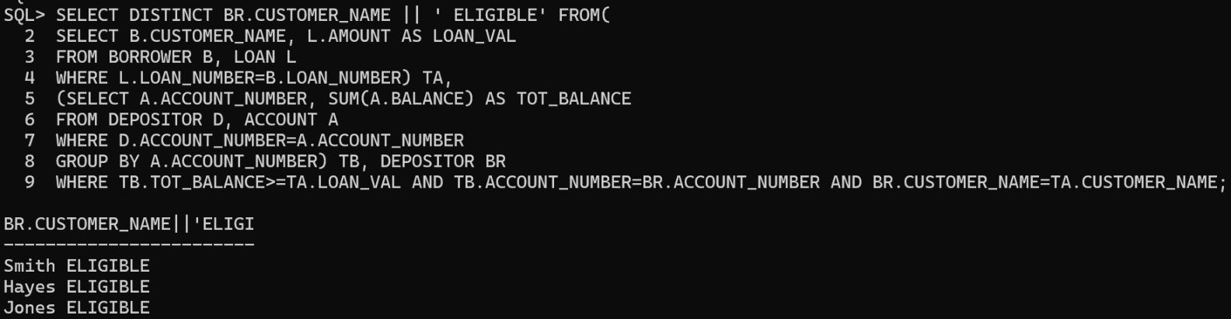

7

SELECT CUSTOMER_NAME ||' Elite' FROM(

SELECT CUSTOMER_NAME, SUM(BALANCE) AS TOT_BALANCE

FROM DEPOSITOR D, ACCOUNT A

WHERE D.ACCOUNT_NUMBER=A.ACCOUNT_NUMBER

GROUP BY CUSTOMER_NAME) A,

(SELECT AVG(BALANCE) AS AVG_BALANCE

FROM ACCOUNT A) B

WHERE A.TOT_BALANCE> B.AVG_BALANCE+500;

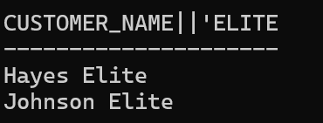

SELECT CUSTOMER_NAME ||' Moderate' FROM(

SELECT CUSTOMER_NAME, SUM(BALANCE) AS TOT_BALANCE

FROM DEPOSITOR D, ACCOUNT A

WHERE D.ACCOUNT_NUMBER=A.ACCOUNT_NUMBER

GROUP BY CUSTOMER_NAME) A,

(SELECT AVG(BALANCE) AS AVG_BALANCE

FROM ACCOUNT A) B

WHERE A.TOT_BALANCE<= B.AVG_BALANCE+500 AND A.TOT_BALANCE>=B.AVG_BALANCE-500;

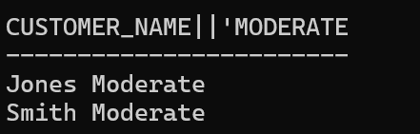

SELECT CUSTOMER_NAME ||' Poor' FROM(

SELECT CUSTOMER_NAME, SUM(BALANCE) AS TOT_BALANCE

FROM DEPOSITOR D, ACCOUNT A

WHERE D.ACCOUNT_NUMBER=A.ACCOUNT_NUMBER

GROUP BY CUSTOMER_NAME) A,

(SELECT AVG(BALANCE) AS AVG_BALANCE

FROM ACCOUNT A) B

WHERE A.TOT_BALANCE< B.AVG_BALANCE-500;

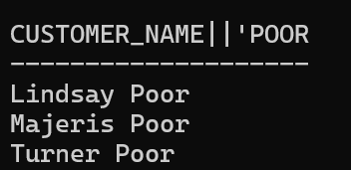

8

SELECT DISTINCT B.BRANCH_NAME, B.BRANCH_CITY, B.ASSETS

FROM CUSTOMER C, BRANCH B

WHERE C.CUSTOMER_NAME NOT IN

(SELECT D.CUSTOMER_NAME

FROM DEPOSITOR D, ACCOUNT A

WHERE D.ACCOUNT_NUMBER=A.ACCOUNT_NUMBER) AND

C.CUSTOMER_CITY=B.BRANCH_CITY;

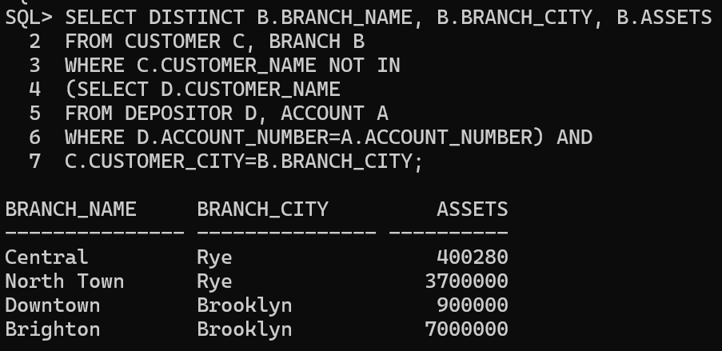

9

CREATE TABLE NEW_CUSTOMER AS SELECT * FROM CUSTOMER WHERE 1=2;

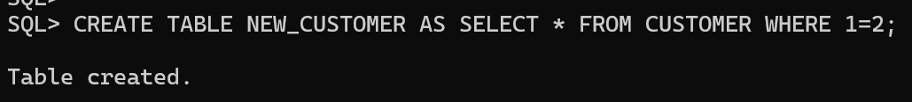

10

INSERT INTO NEW_CUSTOMER

(SELECT DISTINCT C.CUSTOMER_NAME, C.CUSTOMER_STREET, C.CUSTOMER_CITY

FROM CUSTOMER C, (SELECT CUSTOMER_NAME

FROM DEPOSITOR WHERE ACCOUNT_NUMBER IS NOT NULL) D,

(SELECT CUSTOMER_NAME

FROM BORROWER WHERE LOAN_NUMBER IS NOT NULL) B

WHERE C.CUSTOMER_NAME=D.CUSTOMER_NAME OR C.CUSTOMER_NAME=B.CUSTOMER_NAME);

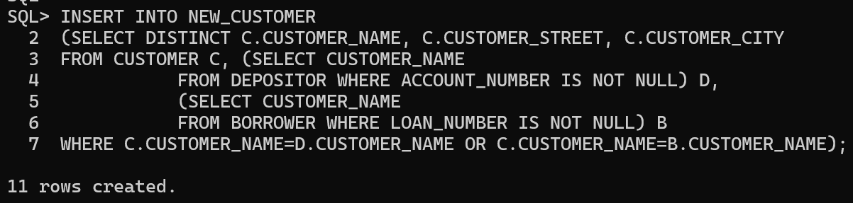

11

ALTER TABLE NEW_CUSTOMER ADD STATUS VARCHAR2(15);

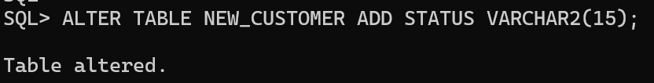

12

UPDATE NEW_CUSTOMER

SET STATUS = CASE

WHEN

CUSTOMER_NAME IN

(SELECT DISTINCT TA.CUSTOMER_NAME

FROM

(SELECT SUM(A.BALANCE) AS BAL, D.CUSTOMER_NAME

FROM DEPOSITOR D, ACCOUNT A

WHERE D.ACCOUNT_NUMBER=A.ACCOUNT_NUMBER

GROUP BY D.CUSTOMER_NAME) TA,

(SELECT SUM(L.AMOUNT) AS LO, B.CUSTOMER_NAME

FROM BORROWER B, LOAN L

WHERE B.LOAN_NUMBER=L.LOAN_NUMBER

GROUP BY B.CUSTOMER_NAME) TB

WHERE TA.BAL>TB.LO AND TA.CUSTOMER_NAME=TB.CUSTOMER_NAME)

THEN 'In Savings'

WHEN

CUSTOMER_NAME IN

(SELECT DISTINCT TA.CUSTOMER_NAME

FROM

(SELECT SUM(A.BALANCE) AS BAL, D.CUSTOMER_NAME

FROM DEPOSITOR D, ACCOUNT A

WHERE D.ACCOUNT_NUMBER=A.ACCOUNT_NUMBER

GROUP BY D.CUSTOMER_NAME) TA,

(SELECT SUM(L.AMOUNT) AS LO, B.CUSTOMER_NAME

FROM BORROWER B, LOAN L

WHERE B.LOAN_NUMBER=L.LOAN_NUMBER

GROUP BY B.CUSTOMER_NAME) TB

WHERE TA.BAL<TB.LO AND TA.CUSTOMER_NAME=TB.CUSTOMER_NAME)

THEN 'In Loan'

ELSE

'In Breakeven'

END;

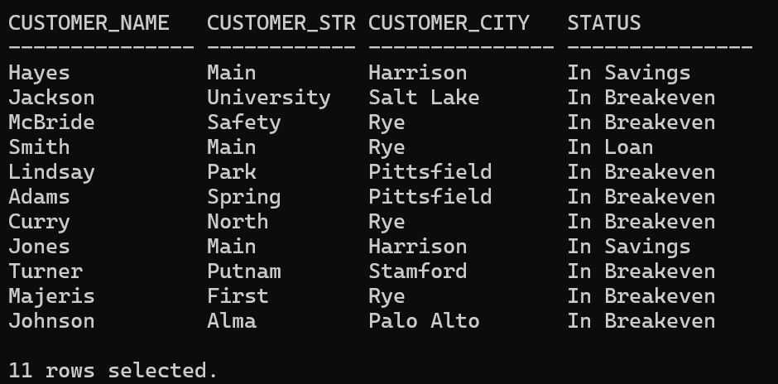

Problems I faced:

I faced problems while joining the tables and also while dealing with null and not null values. I also faced some problems while using the EXTRACT function as they were something I’ve never worked with before.

SUBMITTED BY

MEHREEN HOSSAIN CHOWDHURY

210041219